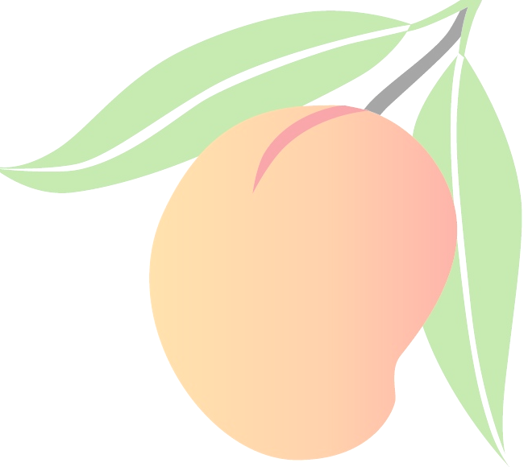



Cumnock Primary is selling 7kg trays of mangoes: picked, packed & delivered to Cumnock (or nearby as needed*) early December

Cost per tray: $28
Order & pay by: Saturday 25 October

For further information contact: Skye Keatinge at cumnockpublicschoolpandc@gmail.com

To order your mango case(s!) complete this form & pay by:
- cash or card at the Cumnock School office
- the Spriggy App
- bank deposit to Cumnock Public School:
BSB:062573 A/C No: 10031543

Mangos delivered early December – we will advise the exact date as soon as the farm confirms with us in November

*a delivery will also be made to Yeoval and Molong
_____________________________________________________
MANGO ORDER FORM
Name: ______________________________________
Contact Number: _______________________________
Delivery location: Cumnock Primary / Yeoval / Molong
Number of cases: __________
Total paid ($28/case): $____________
Method of payment: cash / card / Spriggy / bank transfer

